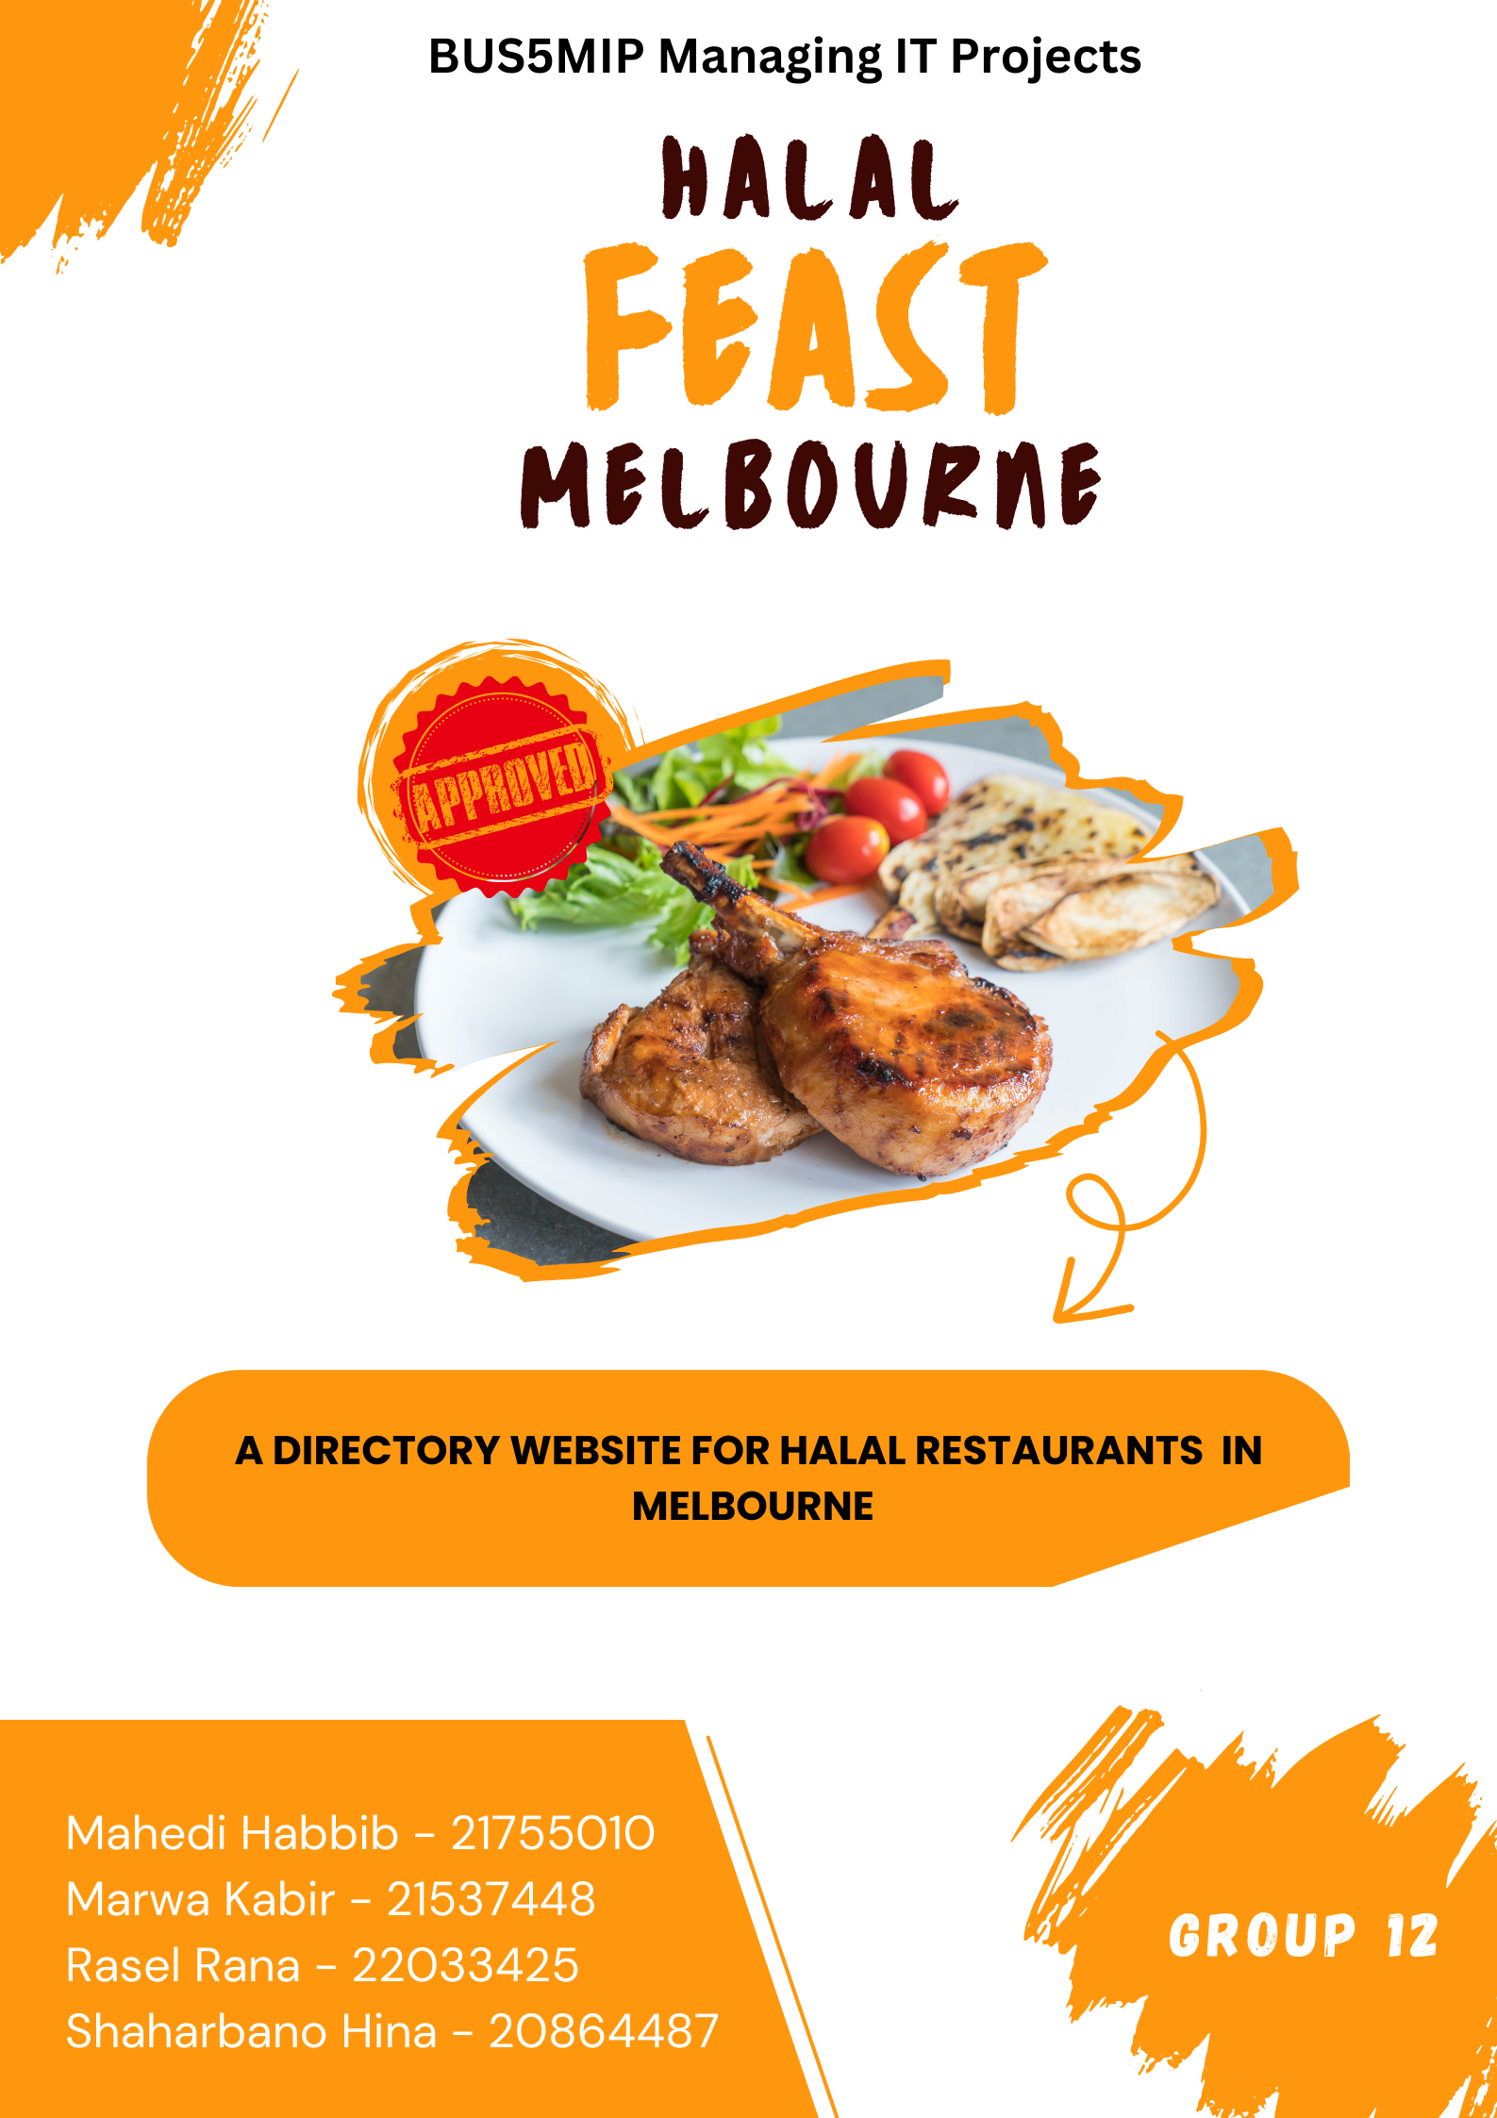

# **Table of Contents**

**Contents**

Table of Contents 2

Table of Figures 3

1. Executive Summary 5

1.1 Project Overview 5

1.2 Key Objectives 6

2. Project Information 7

2.1 Project Scope 8

2.2 Project Deliverables 8

2.3 Assumptions 9

2.4 Constraints 10

2.5 Future Goals and Vision 11

3. Project Team Structure 11

3.1 Project Roles and Responsibilities 12

4. Project Approach 13

4.1 Agile Approach 13

4.2 Development strategy 14

4.2.1 Requirements Gathering and Analysis 15

4.2.2 System Architecture and Technical Design 15

4.2.3 Sprint Planning and Iterative Development 16

5. Governance and Reporting 16

5.1 Work Breakdown Structure (WBS) 16

5.2 RACI Diagram: Roles and Responsibilities 17

5.3 Stakeholder Management Strategy 18

5.4 Communication plan 18

6. Project control 18

6.1 Schedule & Dependencies Management 18

6.2 Key Milestones and Deliverables 20

6.2.1 Initial Stage of The Project 20

6.2.2 Project on Track 21

6.2.3 Project Closure 22

6.2 Financial Management 22

6.3 Risk Management 24

7. Quality Management 24

7.1 Application of ISO 9001 25

7.2 Data Protection and ISO 27001 Compliance 25

7.3 Essential Quality Criteria and Implementation 26

8. Project Monitoring and Control 28

8.1 Status Reporting 28

8.2 Performance Metrics 28

8.3 Change Control Process 29

8.4 Lessons Learned 30

9. Appendix 31

10. References 34

# **Table of Figures**

Figure 1- SMART principles 7

Figure 2 - Project Team 12

Figure 3 - Roles and Responsibilities 13

Figure 4 – WBS 17

Figure 5 - RACI Table 18

Figure 6 - Milestones and Deliverables 21

Figure 7 - Website Initiation 22

Figure 8 - Key Stakeholder 23

Figure 9 - Cost Estimates 24

Figure 10 - Risk Management 25

Figure 13 - Stakeholder Engagement Hierarchy 33

Figure 14 - Stakeholder Communication Frequency and Methods 33

Figure 15 - Gantt chart 34

# **1. Executive Summary**

## **1.1 Project Overview**

The Halal Feast Melbourne directory website is designed to offer a user-friendly platform that allows consumers to easily discover halal food options across Melbourne. This project aims to address the growing need within the Muslim community, as well as among health-conscious individuals, to access restaurants that strictly adhere to Islamic dietary laws. In Islam, the consumption of halal food goes beyond mere dietary observance; it is a form of worship and an integral part of the Islamic way of life, influencing not just diet but behaviour, speech, and overall conduct (Gul et al., 2022).

In Australia, where Muslims make up only about 2.2% of the population, obtaining halal food can be a significant challenge (Imran Ahmed, 2023). The "Halal Feast Melbourne" website aims to bridge this gap by providing verified halal restaurant listings, complete with detailed, up-to-date information on reviews, menus, and special promotions. While the platform is designed to serve the Muslim community, it also appeals to a broader demographic, including culturally diverse and health-conscious consumers who value halal food for its emphasis on cleanliness, ethical sourcing, and stringent adherence to health and safety standards (Azam & Abdullah, 2020).

In addition to benefiting consumers, this project is also positioned to support local halal-certified businesses by enhancing their visibility and providing a platform through which they can reach a broader audience. Just as halal certification has proven to be a vital business model in countries like Canada, where it helps build trust and assures food safety in both domestic and export markets (Gul et al., 2022), the Halal Feast Melbourne directory will uphold similar standards locally. The website will emphasize authenticity and verified halal certifications, addressing common challenges in the halal market related to trust and traceability, and fostering confidence within Melbourne’s diverse Muslim population by meeting their cultural and religious needs.

Aligning with global best practices and Islamic principles, Halal Feast Melbourne aims to provide a seamless experience for both consumers and businesses. The project reinforces halal as a crucial component not only of the Muslim way of life but also of an expanding trend in ethical consumerism, appealing to a wider audience that values ethical food practices, transparency, and quality.

## **1.2 Key Objectives**

The primary objective of the "Halal Feast Melbourne" project is to develop a directory website that meets the growing demand for halal-certified dining options in Melbourne. The project’s core deliverables focus on both meeting the needs of consumers and providing local businesses with a platform to expand their reach. Key deliverables include:

**Seamless Search Experience**: An interactive platform that allows users to search for halal restaurants based on location, cuisine, and price range. The goal is to ensure that users can efficiently find dining options within one minute, providing a smooth and engaging experience.

**Continuous Updates**: Regularly updated restaurant listings, including verified halal certifications and promotional deals. By launch, at least 5-10 restaurants will be listed, with a mechanism in place for ongoing updates.

**Support for Local Businesses**: A space for halal restaurant owners to enhance their visibility through profiles, user reviews, and ratings. The system will allow restaurant owners to create and manage profiles, with at least three restaurants participating during the pilot phase.

**Secure Management for Restaurant Owners**: A login system that allows restaurant owners to manage their listings, update menus, and promote special offers. This secure feature will be implemented using simple plugins, with at least three owners successfully logging in by Week 6.

**Compliance with Halal and Data Regulations**: Ensuring that all restaurant listings are compliant with halal certification standards and data protection regulations, with 100% of listed restaurants providing verified certification details.

These deliverables are aligned with the SMART framework, ensuring that each objective is clear, measurable, and time-bound, as shown in Figure 1. This approach ensures the project remains focused and aligned with the expectations of stakeholders, offering measurable progress and tangible outcomes.

|  |  |  |  |  |  |
| --- | --- | --- | --- | --- | --- |
| **Objective** | **Specific** | **Measurable** | **Achievable** | **Relevant** | **Time-bound** |
| **Seamless Search Experience** | Create a basic search feature allowing users to find halal restaurants by location and cuisine. | Ensure 50% of test users find the restaurant they need in 1 minute. | Utilize existing templates or website builders like Ecwid | Simplifies the search process for users looking for halal food. | Complete the basic feature by 7th week |
| **Continuous Updates** | Add 5-10 initial restaurant listings with verified halal certifications. | Achieve at least 5-10 listings by the launch. | Gather data from a few local restaurants through online research or visits. | Keeps the directory relevant for the initial phase. | Add all initial listings by 8th week. |
| **Support for Local Businesses** | Provide a platform for restaurant owners to create and manage basic profiles. | At least 3 restaurants create profiles during the pilot phase. | Reach out to a small number of restaurant owners via email or visits. | Helps restaurant owners reach new customers, even with minimal engagement. | Secure restaurant participation by 8th week. |
| **Secure Management for Restaurant Owners** | Implement a simple login system for owners to edit their profiles. | Ensure that at least 3 restaurant owners successfully log in. | Use simple plugins or CMS tools to set up login functionality. | Important for restaurant owners to maintain control of their information. | Implement the system by 9th week. |
| **Compliance with Halal and Data Regulations** | Ensure listings meet basic halal certification standards and adhere to simple privacy guidelines. | Ensure 100% of listed restaurants provide halal certification details. | Collaborate with a limited number of restaurants that already have certifications. | Builds user trust by ensuring the authenticity of halal claims. | Verify all certifications by the end of the project. |

Figure 1- SMART principles

# **2. Project Information**

|  |  |
| --- | --- |
| **Project Name** | Halal Feast Melbourne |
| **Group Number** | 12 |
| **Project Manager** | Mahedi Habib |
| **Project Sponsors** | Australian Halal Authority & Advisers, Steggles |
| **Project Stakeholders** | Maha Restaurant, Podok Rempah, & Sezar Restaurant |
| **Project Link** | https://halalfeastmelbourne.company.site/ |

## **2.1 Project Scope**

At the heart of the website is a dynamically searchable database where users can filter halal restaurants based on location, cuisine, price range, and reviews. The technical foundation will be built using a robust content management system (CMS) platform such as Ecwid to enable easy content management, scalable updates, and seamless user experiences across devices. The scope baseline includes project scope, work breakdown structure (WBS), and project deliverables, all of which were managed through formal change control processes.

Compliance with halal certification standards from Australian Halal Authority & Advisers is a key focus of the project, which will involve ensure listings are regularly checked and updated based on the validity of halal certifications. Additionally, user engagement will be maintained through the implementation of interactive features such as ratings, reviews, and real-time feedback, all powered by an intuitive CMS. Regular monitoring of web traffic, user activity, and feedback will be set up using analytical tools like Google Analytics, which will enable future iterations of the website to be data-driven and responsive to user needs.

The project will also cover SEO (search engine optimization) best practices to enhance the website’s visibility in search engines, ensuring that halal restaurant listings are easily discoverable by consumers.

## **2.2 Project Deliverables**

Directory is entirely controlled and managed by the project team, ensuring both accuracy and quality in every listing and interaction. The focus is on practicality and long-term growth, ensuring the platform not only meets current user needs but also anticipates future expansion.

One of the core features of the platform is the Interactive Search Tool. This tool has been designed with the end-user in mind, allowing for effortless searching based on location, cuisine type, and price range. Users can narrow down their halal dining options in under a minute, ensuring a quick and satisfying experience. During Week 4, the project team integrated Google Maps APIs and advanced filtering systems, which were tested and refined during user acceptance tests (UATs) held in Week 6. Feedback collected from initial test users—primarily members of the Muslim community and university students—highlighted the need for improved filter options based on dietary preferences, such as gluten-free and vegetarian, which were then incorporated into the final design.

The platform launched with 5-10 verified halal-certified restaurants, carefully curated by the project team. Each restaurant listing features detailed information, including menus, pricing, and halal certifications that have been personally verified by the team. As a fully managed directory, restaurant owners do not have access to update their listings. Instead, the project team works closely with the restaurants to ensure that all data remains accurate. A dedicated team member manually updates menus and special offers, and this process was automated using Google Sheets and Firebase by Week 3, streamlining data collection.

A major priority of the project was maintaining the integrity of halal certifications. The Halal Certification Verification System was developed during Week 2 to ensure that all restaurants listed comply with halal standards. Certification documents were submitted directly to the project team, who cross-verified them with local halal certification authorities before adding restaurants to the platform. In addition, the website’s backend ensures compliance with data privacy laws, particularly the Australian Privacy Act, with Google Firebase providing secure hosting and SSL encryption to safeguard both user and business data.

Beyond the initial functionality, the project was designed with scalability in mind. Although more advanced features, such as restaurant reservations, table bookings, and integrations with food delivery services, are not part of the initial launch, the platform’s architecture was built to support future upgrades. During Week 5, the development team ensured that the site’s backend could be easily expanded, allowing the addition of more restaurants or even entire cities without the need for major redevelopment. This scalability ensures the platform is ready to evolve as user demand grows.

## **2.3 Assumptions**

The project assumes that restaurant owners will actively participate by providing halal certification documents and continuously updating their listings. It also assumes that the necessary technical infrastructure, such as stable internet connections and server hosting capabilities, will be in place throughout the project lifecycle. In addition, the availability of a sufficient development budget and access to skilled web development resources—whether in-house or contracted—are assumed, as these are essential to delivering the platform on time and within scope.

Another assumption is that there will be a sufficient market demand for such a platform. With halal food being an integral part of the Muslim way of life, it is expected that there will be a strong user base eager for such a centralized directory. Moreover, the assumption extends to consumers finding value in a dedicated platform, assuming that they are currently underserved by existing restaurant listing websites that lack halal certification filters. It is assumed that the platform will scale easily, allowing for future growth and feature additions as needed, without requiring major architectural overhauls. To reduce the risk factors our team maintain an Assumptions Log, which were reviewed regularly during each sprint cycle to ensure that any new risks arising from assumptions are promptly identified and managed.

## **2.4 Constraints**

The project operates under several key constraints, with the most pressing being budgetary limitations. Given that the project is being developed by a university student team, the financial resources available for development, hosting, and marketing are limited. This impacts both the scope of the features that can be developed and the extent to which third-party integrations can be incorporated in the initial release. The project also faces a strict timeline, as the launch needs to coincide with a pre-determined deadline, limiting the team’s ability to implement all the desired features or undertake extensive testing phases. However, we worked within a strict schedule baseline and cost baseline, monitoring through regular project reports to ensure adherence to both time and budget.

From a technical standpoint, the project must adhere to specific technological constraints, such as using pre-selected CMS platforms and ensuring the website complies with data privacy regulations such as the GDPR. Regulatory constraints also apply to halal certification standards, which were upheld in the verification process for each restaurant. Furthermore, the project is constrained by the availability of human resources; as a student-led initiative, the team has had limited technical expertise and time, which affected both the quality of the deliverables and the speed of development.

## **2.5 Future Goals and Vision**

The project has a clear roadmap for expansion. After the successful launch of the platform in Melbourne, the next phase will focus on expanding the directory to cover other major cities in Australia, and potentially New Zealand. The aim is to build a national—and eventually regional—directory of halal restaurants, supported by partnerships with halal certification bodies and local governments.

On the contrary, functionality, future iterations of the platform will incorporate features such as restaurant reservation systems, food delivery service integrations, and a dedicated mobile application. The long-term goal is to establish Halal Feast Melbourne as a trusted and widely used platform for halal dining, not only serving the Muslim community but also appealing to non-Muslim, health-conscious consumers who are increasingly seeking ethically sourced and halal-certified food options. By staying at the forefront of digital technology, consumer preferences, and halal food standards, the platform aims to become an essential resource for halal food lovers across Australia and beyond.

# **3. Project Team Structure**

A well-defined structure of roles and responsibilities was established using the RACI (Responsible, Accountable, Consulted, Informed) matrix, in line with PMI's *Human Resource Management* guidelines. The RACI matrix provided clear responsibility assignments for every task, ensuring that all team members were aware of their roles, and it facilitated collaboration and accountability across the project lifecycle.

The project team utilized Jira to monitor task progress, manage project performance, and share updates with stakeholders. This allowed the team to track Key Performance Indicators (KPIs) and ensure all tasks were completed according to the timeline. Regular Zoom calls with the team members and continuous communication with the stakeholders helped provide further visibility, aligning the project with stakeholder expectations through effective performance reporting.

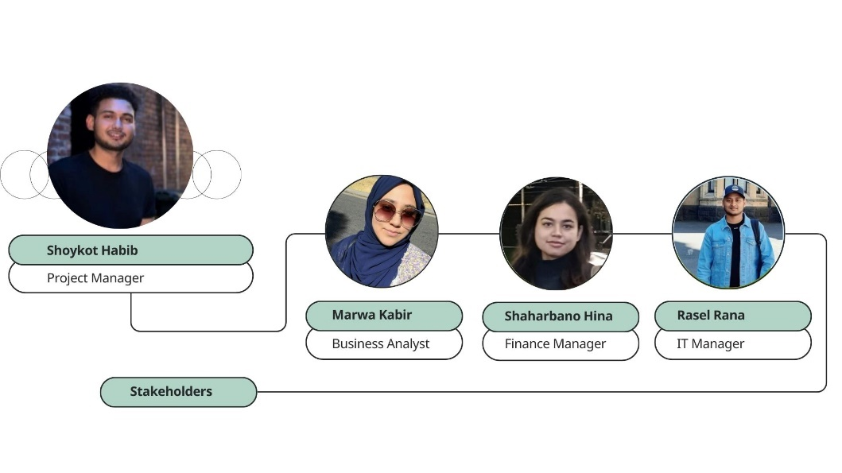

Figure 2 - Project Team

## **3.1 Project Roles and Responsibilities**

|  |  |  |  |
| --- | --- | --- | --- |
| **Team Member** | **Role** | **Key Responsibilities** | **RACI Designation** |
| **Shoykot Habib** | Project Manager | Managed overall project planning and execution, ensuring deadlines were met. Responsible for guiding the team and decision-making processes. Engaged in regular Jira updates and conducted Zoom calls for stakeholder engagement. | *Accountable*: Project’s overall success; *Responsible*: Coordinating project execution and decision-making. |
| **Marwa Kabir** | Business Analyst | Managed team meetings, assigned tasks, tracked progress, and ensured effective communication with stakeholders. Provided regular reports through Jira and Zoom. Responsible for stakeholder communication and engagement. | *Responsible*: Managing the project schedule and stakeholder communication; *Consulted*: On business and strategic decisions. |
| **Shaharbano Hina** | Finance Manager | Collected financial data, managed project budgeting, and ensured cost management was on track. Engaged with stakeholders regarding financial updates via Jira. Provided cost analysis and budget adjustments based on progress. | *Accountable*: Financial planning and reporting; *Responsible*: Managing the project budget and financial updates. |
| **Rasel Rana** | IT Manager | Led the technical development team and ensured the website's design and functionality met the required specifications. Used Jira for tracking technical progress and provided updates to stakeholders through Zoom. | *Responsible*: Website development and implementation; *Informed*: Providing stakeholders with technical progress updates. |

Figure 3 - Roles and Responsibilities

# **4. Project Approach**

## **4.1 Agile Approach**

The Agile methodology was effectively applied to the development of the directory website for halal food in Melbourne, ensuring a flexible and adaptive project structure. The project was broken down into iterative sprints, each lasting two weeks, following a Scrum framework. This allowed the team to deliver incremental improvements, with each sprint focusing on key functional components such as the restaurant search functionality, halal certification integration, and user profile management.

The iterative nature of Agile meant that each sprint delivered a Minimum Viable Product (MVP), which was then tested and validated by a selected group of stakeholders and end-users. Regular user acceptance testing (UAT) cycles were conducted at the end of each sprint, incorporating feedback loops into the product development process. This helped the team remain aligned with user needs and allowed for rapid adjustments to the site’s functionality based on real-world feedback.

The team utilized Jira for sprint planning, task tracking, and backlog management, ensuring visibility into progress for all team members. Jira’s built-in reporting tools, such as burn-down charts and velocity tracking, enabled the project manager to monitor the team’s performance, identify bottlenecks, and adjust resources as necessary to maintain momentum.

Daily stand-up meetings were held using Zoom to ensure continuous communication and alignment between team members, while sprint reviews and retrospectives provided opportunities to reflect on the development process and make improvements for future sprints. The RACI matrix was employed to assign specific roles and responsibilities for each deliverable, ensuring accountability and role clarity at every stage. There is a glimpse of some initial stakeholder user stories and acceptance criteria for directory features portrayed in Figure 11 (**Appendix**)

Frequent Sprint reviews and product demos kept the project transparent to key stakeholders enabling valuable feedback and adjustments to the product roadmap. The iterative development process allowed the incorporation of industry trends, such as the growing demand for online halal food directories and improved user experiences, ensuring that the website stayed competitive in the marketplace. The team’s commitment to continuous improvement was further enhanced by conducting agile retrospectives at the end of each sprint. These retrospectives allowed team members to assess the sprint’s successes and identify areas for improvement, contributing to process refinement and adaptability to dynamic project requirements.

Employing Agile practices, the project was not only completed on time but also resulted in a high-quality, user-focused product that can be easily enhanced in the future. The flexibility inherent in the Agile framework allowed the team to stay responsive to evolving user demands, ensuring that the platform developed into a robust and scalable solution.

## **4.2 Development strategy**

The major goal was to create a mobile-friendly directory that provided seamless search capabilities and a pleasant user experience for both customers and restaurant owners. The project was broken down into essential phases, each with a unique technical and functional purpose.

Figure 3- Development Strategy

### **4.2.1 Requirements Gathering and Analysis**

The initial phase involved extensive stakeholder engagement to collect and analyse user requirements. Surveys and interviews helped to define the core functionalities, such as searching for halal restaurants by location, filtering by cuisine, and sorting by price range. These user stories were documented in Jira, forming the foundation for sprint planning.

### **4.2.2 System Architecture and Technical Design**

Based on the gathered requirements, the system architecture was designed to ensure scalability, security, and ease of future expansion. The platform is developed within a robust CMS named ‘Ecwid’ to streamline content management and enable updates. Key components of the technical architecture included:

**Front-End Development**: Built using HTML5, CSS3, and JavaScript to ensure responsiveness across devices.

**Back-End Development**: A CMS-driven backend for managing data, user profiles, and restaurant listings.

**Database**: A cloud-based relational database to handle restaurant data, halal certifications, and user interactions.

**Security**: SSL encryption, GDPR compliance, and secure user authentication for both users and restaurant owners.

### **4.2.3 Sprint Planning and Iterative Development**

Implementation of Agile principles let the project divided into bi-weekly sprints, each delivering key functionalities. Few crucial sprints focused on core features as illustrated in Figure 12 (**Appendix**).

# **5. Governance and Reporting**

## **5.1 Work Breakdown Structure (WBS)**

Figure 4 provides a clear, organized breakdown of tasks essential for developing the halal food directory website in Melbourne. It ensures effective resource allocation, task accountability, and progress tracking. By structuring each project phase, from planning to post-launch, the WBS facilitates seamless execution and timely delivery of key milestones**.**

Figure 4 – WBS

## **5.2 RACI Diagram: Roles and Responsibilities**

This briefly shows how roles and responsibilities are assigned, maintaining clarity and accountability

|  |  |  |  |  |
| --- | --- | --- | --- | --- |
| **Task** | **Responsible** | **Accountable** | **Consulted** | **Informed** |
| **Project Planning** | Project Manager | Project Manager | Business Analyst, IT Manager | Stakeholders |
| **Website Design** | IT Manager | Project Manager | Business Analyst, Designer | Stakeholders |
| **Halal Certification Verification** | Business Analyst | Business Analyst | Project Manager | Stakeholders |
| **Content Creation** | Business Analyst | Project Manager | IT Manager, Designer | Stakeholders |
| **Website Development** | IT Manager | Project Manager | Developer, Business Analyst | Stakeholders |
| **Testing** | IT Manager | Project Manager | Developer, Testing Team | Stakeholders |
| **Deployment** | IT Manager | Project Manager | Developer | Stakeholders |
| **Performance Monitoring** | IT Manager | IT Manager | Business Analyst, Project Manager | Stakeholders |
| **Financial Management** | Finance Manager | Finance Manager | Project Manager | Stakeholders |
| **Stakeholder Communication** | Project Manager | Project Manager | Business Analyst | Stakeholders |

Figure 5 - RACI Table

## **5.3 Stakeholder Management Strategy**

Stakeholder Management Strategy to real-time demands and varying levels of influence, the project ensured effective communication and conflict resolution, keeping the project aligned with stakeholder expectations. The use of sprints allowed for flexibility in addressing stakeholder requests, prioritizing them based on their alignment with the project’s core goals and feasibility within the development timeline. This strategy was instrumental in the successful launch of the directory website.

Refer to Figure 13 (**Appendix**) to understand Stakeholder Engagement Hierarchy and their influence on the project.

## **5.4 Communication plan**

Stakeholders, both internal (team members) and external (restaurant owners, certification bodies, and users), were kept informed through a variety of channels to ensure the project stayed on track and met all stakeholder needs. Refer to Figure 14 (**Appendix**).

# **6. Project control**

## **6.1 Schedule & Dependencies Management**

The Gantt chart in Figure 15 (**Appendix**) tracked tasks, deadlines, and dependencies, while highlighting key milestones like website back-end completion, content creation, website front-end development, and final deployment. It allowed the team to identify bottlenecks early, adjust timelines, and manage delays through a formal change control process, ensuring critical milestones were met efficiently. The RACI matrix in Figure 5 ensures that duties are explicitly assigned, promoting openness and accountability throughout the project.

In addition, Figure 3 clear delineation of duties across project phases facilitated seamless collaboration, with tasks such as content creation, financial tracking, technical implementation, and stakeholder communication all being handled efficiently by the respective responsible and accountable team members. The structure detailed in Figure 1 was pivotal in fostering a collaborative environment, allowing the team to stay aligned with project goals, and driving the project toward a successful completion within the defined timelines.

The project was initially planned to be completed in 60 days, but with realistic expectations and an agile approach, we had planned for an additional 10 buffer days to account for any delays. This gave us the flexibility we needed when certain tasks, such as stakeholder identification and requirement gathering, extended beyond their planned timelines.

One of the key aspects of the Gantt chart was its ability to highlight the status and risk level of each task, using a color-coded system. Low-risk tasks were marked in light blue, medium-risk in purple, and high-risk in red, making it easy for the project manager to identify which tasks needed more attention. For instance, website framework development was classified as medium risk because it was both technically complex and required close collaboration with the content team. The high-risk tasks, like functional testing and usability testing, were given extra focus to ensure they were completed on time, as any delays in these would have affected the entire project timeline.

As we moved through the different phases of the project from Project Initiation to Website Backend and Content Creation the Gantt chart became invaluable for keeping the team aligned. Each team member had access of the RACI matrix, and the chart helped us visualize how the work flowed from one phase to the next. For example, while the IT Manager was integrating features, the content team was simultaneously working on gathering restaurant details, which allowed us to optimize our time and avoid bottlenecks. The project manager, having an overview of all tasks, could easily shift resources if a particular area was falling behind, ensuring that the overall project remained on track during the sprint figure 4.2iii.

Despite some delays in the content creation phase, where restaurant certifications took longer to verify than expected, the buffer days allowed us to recover without affecting subsequent stages. The buffer days were not just reactive but were part of our proactive planning, ensuring that we didn’t just meet deadlines, but did so with high quality and thorough testing.

## **6.2 Key Milestones and Deliverables**

In essence, the Gantt chart didn’t just track our progress; it was a living document that guided the entire team through every phase of the project, from initiation to the final project closure. Its integration with our sprint cycles ensured that we always had a clear picture of where we stood, what risks we were managing, and how we could continuously adjust to stay on track.

Figure 6 - Milestones and Deliverables

The project’s milestones were meticulously scheduled across a 10-week timeline. In Week 1, the Project Initiation phase kicked off, where the team conducted stakeholder interviews, including halal restaurant owners, to understand their needs. Menus, certifications, and marketing material were collected during this phase. Feedback from restaurant owners indicated a strong preference for centralized management of their profiles, which confirmed the decision that the project team would handle all updates directly.

### **6.2.1 Initial Stage of The Project**

The Content Creation phase took place over Weeks 2 and 3. This period focused on designing the visual framework of the platform, including creating the logo, building the website structure using WordPress, and adding essential restaurant information. The team worked collaboratively using Jira, and tasks such as updating restaurant details and creating promotional materials were assigned through Scrum meetings. The creation of real-time promotional deals was finalized, with restaurant promotions integrated through the Ecwid plugin.

Figure 7 - Website Initiation

### **6.2.2 Project on Track**

Website Development, which occurred between Weeks 4 and 9, formed the core of the project. During this time, the search function, Google Maps integration, and review system were built and tested. The development team encountered some technical challenges, particularly in filtering options, but by Week 7, adjustments had been made based on initial UAT feedback. Early testers found it difficult to locate restaurants based on proximity, leading to the enhancement of geo-targeted search options. The review system, which allows users to leave ratings and comments, was integrated in Week 8, ensuring that the platform offers real-time user interaction and feedback capabilities. A beta version of the platform was shared with a select group of students and local users, whose insights helped optimize performance before the final release.

### **6.2.3 Project Closure**

Finally, in Week 10, the project entered the Closure Phase. During this time, formal feedback was gathered through surveys sent to both early users and restaurant partners. The feedback highlighted a high level of user satisfaction with the search features and ease of navigation, although some suggested more detailed filtering for dietary requirements and a dedicated mobile app, which the team logged for future development. The website now has the key stakeholders on the homepage (Figure 8). A comprehensive project review was conducted, and based on lessons learned, a future roadmap was established, identifying key areas for growth, including potential partnerships with local food delivery services.

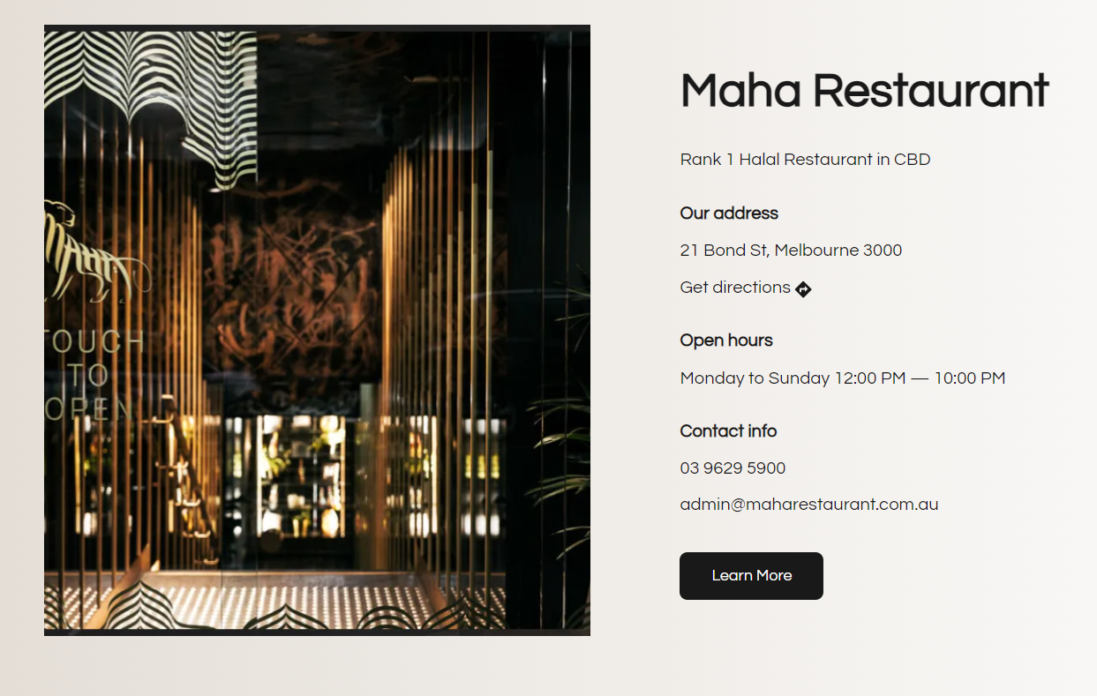

Figure 8 - Key Stakeholder

## **6.2 Financial Management**

The planning phase, a comprehensive cost estimation was conducted, covering both direct and indirect expenses, such as labour costs, resources, and software licensing fees. Throughout the project, the team used a cost tracking tool, like Microsoft Excel, to log expenses and compare them against the allocated budget. Earned Value Management (EVM) techniques were employed to measure the project's financial health and progress. Regular financial reports were generated, and stakeholders were kept informed of the project's financial status through monthly updates.

Figure 9 - Cost Estimates

**Optimizing Resource Allocation**: With 45% of the budget going to project management, it's essential to ensure that time spent by the team is productive. Regular sprint reviews and careful time tracking through tools like Jira can help maximize efficiency and ensure resources are focused on priority tasks.

**Investing in Technology**: The 15% allocated to hardware and software is critical to ensure smooth project execution. Investing in reliable equipment will minimize disruptions. Consider negotiating long-term software contracts to reduce future costs, and ensure hardware comes with support plans to prevent unexpected expenses.

**Controlling Development Costs**: To keep the 11% spent on domain and development within budget, it’s key to manage the scope carefully. Using Agile methodology with clear milestones will help avoid delays and additional costs.

**Optimizing Training and Support**: While 9% of the budget is for training, it’s worth exploring cost-effective online learning platforms to cut down on travel and in-person training costs, allowing for more flexibility and savings.

**Managing Reserves**: The 20% reserved for contingencies provides a safety net for unexpected challenges. Regular risk assessments will help ensure these funds are used only when truly necessary, keeping the project on track without unnecessary spending.

## **6.3** **Risk Management**

Risk Register was maintained and regularly updated. For technical risks like system failures, we implemented automated testing through Continuous Integration (CI) tools, created backup schedules, and used cloud hosting for scalable infrastructure. Early testing in sandbox environments helped mitigate integration risks. For non-technical risks, stakeholder misalignment was managed through frequent check-ins, sprint reviews, and feedback loops. Task prioritization helped address resource constraints, while cost-saving measures (using open-source tools) controlled financial risks. Buffer times in the schedule and daily stand-ups helped prevent delays, ensuring smooth progress toward key milestones. Figure 7 illustrates the key risks, their potential impacts, likelihood, and the mitigation strategies that were employed to keep the project on track

Figure 10 - Risk Management

# **7. Quality Management**

The quality management system (QMS) for the project was designed with a focus on integrating ISO 9001 standards while addressing both conformance and performance auditing. Drawing from the conceptual auditing framework (CAF) proposed by (Abuazza et al., 2020; Khalfan et al., 2020) which highlights the limitations of traditional ISO 9001 audits, we adopted a more process-focused approach. This framework emphasizes the importance of integrating risk management and continuous improvement alongside standard ISO compliance, which directly influenced how we structured our future audits.  
  
To ensure that business and technological quality standards were met*,* ISO 9001 was selected as the guiding framework (Wolniak, 2020). ISO 9001 focuses on delivering consistent quality while improving customer satisfaction. The decision to align with this standard was influenced by the successful implementation of similar QMS frameworks in other projects, where early integration of ISO principles resulted in efficient processes and sustainable growth. This approach allowed us to develop a QMS that aligns with industry best practices and sets the foundation for future scalability.

## **7.1 Application of ISO 9001**

The ISO 9001 framework was applied to manage quality across all phases of the project. This involved the establishment of documented processes for each task, ranging from content verification to system testing. Quality objectives were defined at the outset, ensuring that all components of the project were measured against these predefined standards.

A central element of ISO 9001 is continuous improvement. To implement this, the project incorporated regular review cycles. Weekly quality assessments were conducted, ensuring that both the functional aspects of the platform and its user experience were regularly evaluated. This approach allowed the team to identify and address any issues early, preventing delays or compromises in quality. Drawing from best practices observed in earlier projects, these quality reviews contributed significantly to the platform’s overall reliability.

## **7.2 Data Protection and ISO 27001 Compliance**

In addition to ISO 9001, the project also prioritized information security by incorporating elements of ISO 27001, which provides guidelines for effective information security management systems (ISMS). Although a full ISO 27001 implementation was beyond the immediate scope, key principles such as data encryption, secure access controls, and regular security audits were applied.

To ensure compliance with relevant data protection laws, the project adhered to both the **Australian Privacy Act** and **GDPR** regulations. The use of Microsoft Azure’s integrated security tools facilitated secure data handling and storage, aligning with ISO 27001 standards. This allowed the project to maintain a secure environment for user data, providing a foundation for future scalability without compromising security.

## **7.3 Essential Quality Criteria and Implementation**

**Functional Requirements**: We prioritized the key functions of the website, ensuring users could search, filter, and review halal restaurants. Using Google Firebase for database management allowed us to store and retrieve data efficiently without the need for complex server setups. This was particularly useful for managing restaurant listings and user-generated content like reviews. By integrating Google Maps API, users could easily locate restaurants based on their proximity, enhancing functionality while keeping the platform lightweight and scalable.

**Non-Functional Requirements**: Given our limited resources, we designed the website to be scalable and future-proof. We used Microsoft Azure’s cloud services, which were available through the university, to ensure the platform could handle higher traffic as it grows. The scalability provided by Azure allowed us to manage system resources effectively, ensuring the website remains responsive as more users and restaurants are added. By setting up automatic scaling, we reduced the need for manual intervention, ensuring the system adjusts to peak traffic times without affecting performance.

**Performance**: To maintain high performance, especially during peak periods like Ramadan or community events, we employed Google Cloud Platform (GCP) tools for monitoring server load and traffic spikes. This allowed us to optimize performance by dynamically adjusting resources during high-traffic times. We also utilized Google PageSpeed Insights to identify and fix any bottlenecks that could slow down the website, ensuring a fast and smooth user experience. These tools helped us stay within our budget while ensuring the website performed efficiently under load.

**Accuracy**: Accuracy was critical since restaurant listings had to be reliable. Using Google Sheets, we maintained a central database where we manually verified halal certifications, addresses, and contact details before uploading them to the site. This low-cost but effective method allowed us to ensure that all information on the platform was up-to-date and accurate. The team regularly updated the sheet as new information became available, ensuring that the directory always provided users with correct details.

**Security**: Given the limited budget of a student project, we focused on implementing basic but robust security measures. We used SSL encryption to secure data transmission between the website and users, which was facilitated through Google Firebase Hosting. In addition, we used Azure’s Security Centre to monitor and manage security risks, providing built-in tools to detect and respond to potential threats. This combination of Google and Microsoft tools ensured compliance with data protection regulations like the Australian Privacy Act, while remaining cost-effective and accessible to our team.

**Compatibility**: To ensure the website was accessible across multiple devices, we used Microsoft PowerApps for testing and Google Chrome DevTools for optimizing the platform across various screen sizes. The website was built to be responsive, allowing seamless navigation on both mobile and desktop devices. This compatibility testing ensured that users could access the site regardless of the device they used, without compromising on the quality of the experience.

**Reliability**: Ensuring the site was reliable was key to maintaining user trust. We implemented Google Cloud Backups to automatically back up all essential data at regular intervals. This ensured that, in the event of an issue, data could be restored quickly with minimal downtime. Additionally, Azure Monitoring provided real-time analytics on website uptime and performance, allowing us to identify and resolve potential issues before they could affect users. This proactive approach helped maintain a reliable platform even with our limited technical resources.

**Flexibility**: We ensured the website was built with flexibility in mind, capable of accommodating future growth. Using Azure’s scalable infrastructure, we can easily expand the platform to cover more cities or add new features like restaurant promotions or special events listings without needing a complete overhaul. This flexibility is crucial for maintaining the relevance of the platform as the user base grows and the market evolves.

# **8. Project Monitoring and Control**

The successful completion of the "Halal Directory Website for Restaurants in Melbourne" project can be attributed to effective project monitoring and control mechanisms. Ensuring the project stayed on track while meeting all pre-defined milestones. Throughout the project lifecycle, continuous monitoring and adjustments were made to address challenges and optimize outcomes.

## **8.1 Status Reporting**

From the outset, regular status reporting was a key aspect of maintaining alignment between stakeholders, project team members, and external partners. Weekly progress meetings were conducted to review the overall status, discuss ongoing tasks, and assess potential risks. These reports provided an overview of completed work, work in progress, and any areas that required immediate attention. The reporting structure included metrics related to design and development progress, resource allocation, task completion, and adherence to timelines.

In particular, the project's initial phases, such as market research and data collection, proceeded smoothly, and regular updates ensured that stakeholders were well-informed about the pace of progress. As the project moved into the more complex stages of website development and testing, status reports helped to manage expectations and quickly identify bottlenecks. This allowed for proactive measures to be implemented, such as reallocating resources or adjusting timelines to ensure that the website was delivered on schedule. Importantly, communication with restaurant partners was maintained to update them on the verification process and onboarding onto the platform, ensuring mutual alignment.

## **8.2 Performance Metrics**

To evaluate the project's performance, several key performance indicators (KPIs) were defined during the project planning phase. These KPIs were important in measuring both short-term and long-term success. In terms of website development, the primary KPIs were related to functionality, responsiveness, and security. Specific metrics included the loading speed of pages, uptime during the testing phase, mobile compatibility, and the seamless integration of the restaurant search and review functionalities.

In addition to technical performance, KPIs were also set for user experience and content accuracy. The accuracy of restaurant data, such as halal certification status, address, and contact information, was regularly verified throughout the development process. The initial target was to verify 100% of the restaurant listings before the website launch, and this goal was successfully achieved. Usability testing also played a significant role in determining user satisfaction. Based on feedback from early testers, improvements were made to navigation and search filters, which enhanced the overall user experience.

Post-launch, the website’s success criteria included the number of active users, the frequency of new restaurant additions, and user engagement metrics such as review submissions and time spent on the platform. The KPIs were met with an overwhelmingly positive response. In the first three months, the website exceeded its target of 5,000 active users, and the majority of visitors reported high levels of satisfaction with the directory’s ease of use and reliability.

## **8.3 Change Control Process**

During the project's execution, several changes to the original scope were proposed and carefully managed through a structured change control process. One of the primary changes involved expanding the search functionality to include additional filters such as cuisine type, restaurant location, and delivery options. Initially, the scope only included basic restaurant listings with a simple search feature. However, feedback from stakeholders and initial user testing indicated a need for more sophisticated search tools to improve the user experience.

To manage this scope change, a detailed impact analysis was conducted to assess the implications on cost, timeline, and resources. The integration of these new features required an extension of the development timeline by two weeks, which was communicated to all stakeholders. This change, however, added significant value to the final product, enhancing the usability and relevance of the directory.

Additionally, unforeseen challenges, such as delays in verifying restaurant certifications and integrating the review system, were addressed using contingency plans. The project team quickly adapted by re-prioritizing tasks, ensuring that critical functionalities were delivered on time while secondary elements were completed in subsequent development phases. The clear documentation and transparent communication throughout the change control process minimized disruptions and ensured that the project remained on course.

## **8.4 Lessons Learned**

The lessons learned throughout the project were meticulously documented to guide future projects and improve organizational processes. One key lesson was the importance of early stakeholder engagement. By involving restaurant owners and halal certification bodies in the planning phase, the project team was able to anticipate potential verification delays and streamline the onboarding process. This engagement also helped to foster partnerships, leading to promotional opportunities that benefited both the restaurants and the directory.

Another significant takeaway was the value of flexible development. The initial decision to use modular architecture for the website allowed the team to incorporate additional features, such as advanced search options and a review system, without major rework. This approach saved both time and resources, while allowing for future scalability as the platform grows. Post-launch user feedback emphasized the importance of ongoing updates and responsiveness to user needs. Based on this feedback, the team is now implementing a continuous improvement strategy, with regular updates to restaurant listings and the inclusion of more user-generated content, such as photos and reviews.

# **9. Appendix**

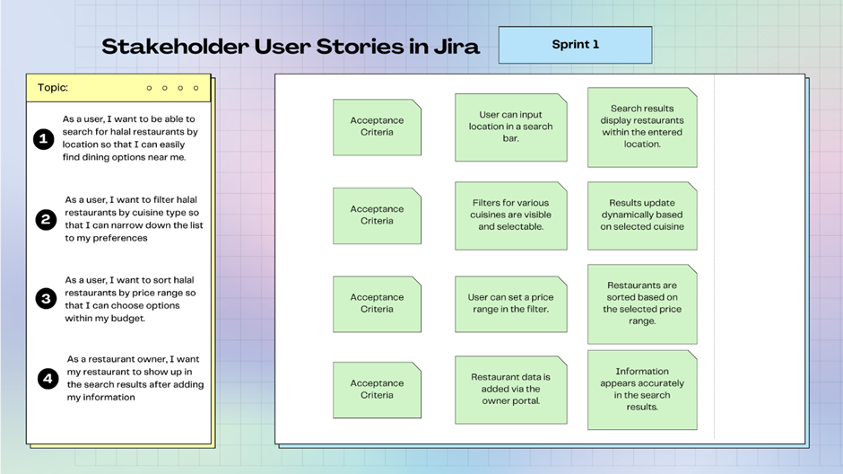

Figure 11 - Stakeholder User Stories

Figure 12 – Agile Sprints

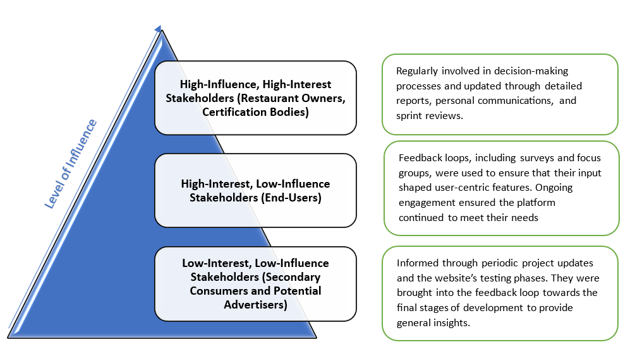

Figure 13 - Stakeholder Engagement Hierarchy

Figure 14 - Stakeholder Communication Frequency and Methods

Figure 15 - Gantt chart

# **10. References**

* Marnewick, A. L., & Joseph, N. (2020). The Importance of Planning for Communication in a Project During the Requirements Process. *IEEE Engineering Management Review, 48*(1), 104–112. https://doi.org/10.1109/EMR.2019.2952563
* Azam, M. S. E., & Abdullah, M. A. (2020). Global halal industry: realities and opportunities. *IJIBE (International Journal of Islamic Business Ethics)*, *5*(1), 47-59.
* Gul, M., Akbar, J., Ikramullah, M., & Raza, A. (2022). International halal industry and its impact on global halal market (A historical review and future business prospect). *Journal of Positive School Psychology*, *6*(7), 5890-5907.
* Imran Ahmed, K. (2023). The advantages of halal food for health and well-being. *Journal of clinical and basic research*, *7*(4), 23-24.
* Abuazza, O. A., Labib, A., & Savage, B. M. (2020). Development of a conceptual auditing framework by integrating ISO 9001 principles within auditing. *International Journal of Quality & Reliability Management*, *37*(3), 411-427.
* Khalfan, I., Said, S., Jamaluddin, Z., & Widyarto, S. (2020). Conceptual framework on quality management practices and operational performance for ISO 9001 certified construction industries. *International Journal of Academic Research in Accounting, Finance and Management Sciences*, *10*(2), 200-210.
* Wolniak, R. (2020). Design in ISO 9001: 2015. *Zeszyty Naukowe. Organizacja i Zarządzanie/Politechnika Śląska*.